**Report**

|  |  |
| --- | --- |
| Date | 22 June 2025 |
| Project Name | Global Energy Trends: A Comprehensive  Analysis of Key Regions and Generation  Modes using Power BI |
| Maximum Marks | 5 Marks |

A report is a comprehensive document that provides a detailed and structured account of data analysis, findings, and insights. It is typically used for in-depth analysis, documentation, and communication of results. Reports are suitable for a diverse audience, including decision-makers, analysts, and stakeholders who need a comprehensive understanding of the data.

Designing a report in Power BI involves connecting to data sources, creating visualizations like charts and graphs, customizing their appearance and interactivity, organizing them logically on the canvas, formatting elements for consistency and clarity, and optionally creating dashboards for a summarized view. Throughout the process, it's essential to consider the audience's needs and ensure the report effectively communicates insights from the data. Finally, iterate based on feedback to continually improve the report's design and usefulness.

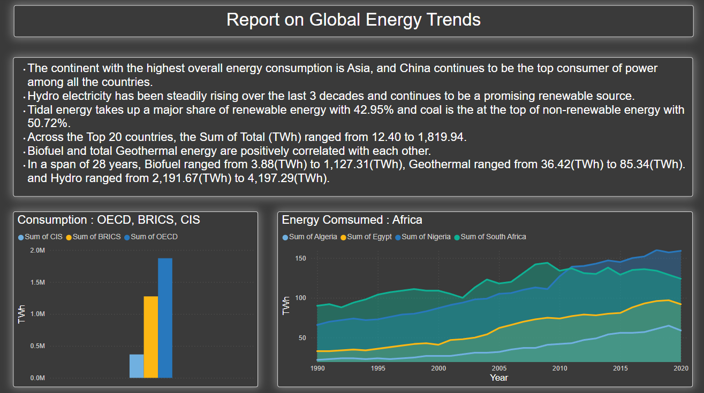

Observations drawn from reports in Power BI can provide valuable insights into business performance and trends.

**1. Trends Over Time**:

**Global and Continental Energy Growth**

* Asia leads the world in total energy consumption, maintaining consistent growth across the 30-year period.
* China has emerged as the top consumer of power, surpassing traditional leaders like the United States since 2010.
* Hydroelectricity has seen a steady and significant rise, confirming its growing role as a renewable energy pillar.
* Tidal energy, although relatively new, now comprises 42.95% of renewable energy share, showcasing a shift toward ocean-based solutions.

**Renewable Energy Evolution (1990–2017)**

* Biofuel increased from 3.88 TWh to 1,127.31 TWh, while Geothermal ranged from 36.42 TWh onwards, indicating a positive correlation between them.
* Renewable sources like Solar PV and Wind have accelerated post-2010, driven by falling costs and global climate targets.

**2. Performance Comparisons**:

**Top 20 Countries:**

* Total energy (TWh) per country ranges from as low as 12.40 TWh to 1,819.94 TWh, showing a significant performance gap.
* The United States, despite declining slightly in recent years, remains a top contributor in both renewable and non-renewable sectors.

**Continent-Level Consumption:**

* Africa has shown modest but consistent growth in energy consumption. Among African nations:
  + South Africa and Egypt lead the region.
  + Nigeria and Algeria have shown gradual upward trends post-2005.
* OECD, BRICS, and CIS regions differ sharply:
  + OECD: Highest average consumption.
  + BRICS: Rapidly growing, led by China and India.
  + CIS: Lowest, with relatively stable trends.

**3. Potential for Segmentation & Strategy**:

Though demographic data is not available in this dataset, regional energy performance can act as a segmentation proxy:

* High-Performing Regions (Asia, North America):
  + These regions can focus on energy optimization and grid modernization.
* Emerging Regions (Africa, Latin America):
  + Focus on energy access and renewable adoption strategies.

**4. Goal Achievement**: **Renewable vs Non-Renewable**

**Current Split**

* Coal leads non-renewables with 50.72% share.
* Hydro dominates renewables with 42.95%.
* Overall, renewables are growing, but non-renewables still form a majority of global energy mix.

Actionable KPIs

* Countries aiming for **net-zero emissions** must focus on:
  + **Reducing coal and oil** dependency.
  + **Boosting wind, solar, and geothermal** development.

**Key Insights:**

| **Observation** | **Insight** |
| --- | --- |
| Top Consumer | China (Rapid rise post-2005) |
| Top Continent | Asia |
| Top Renewable | Hydro (42.95% of total renewable mix) |
| Top Non-Renewable | Coal (50.72%) |
| Emerging Renewable | Tidal energy gaining share |
| African Leaders | South Africa, Egypt |
| BRICS Growth | High, driven by China & India |
| OECD Consumption | Still the highest among groups |

**Recommendations for Decision Makers:**

1. **Policy Shift**: Encourage hydro and tidal investment based on current momentum.
2. **Tech Upgradation**: Countries like India and Brazil should invest in grid-scale battery storage for renewable stability.
3. **Africa Focus**: Provide international support for renewable infrastructure expansion in low-consuming African nations.
4. **Coal Phase-Out**: OECD countries must accelerate coal retirement programs and fund cleaner alternatives.